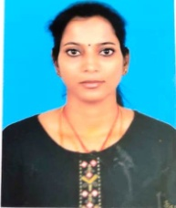

**STAFF PROFILE**

|  |  |  |
| --- | --- | --- |
| Name | : | **Dr.S.KALPANA** |
| Designation | : | **Physiotherapist** |
| Qualification | : | **B.P.T., PGDY.,Dip.FN** |
| Experience | : | **8 Months** |
| Education Institute |  | **Kamalam Viswanathan College of Physiotherapy (2000 to 2007)** |